

**ENSE 471 -** [**User Interface Programming**](https://urcourses.uregina.ca/course/view.php?id=13770)

**Professor: Tim Maciag**

**Milestone 1.2 - Target Customers & Observe**

**Date: January 23, 2019**

**Group Name: UserPro**

**Group Members: Han Gao, Azeezat Lawal, Mansi Patel, Muhammad Ishraf Shafiq Zainuddin**

**Github URL:** [**https://github.com/zainshafiq/User-Interface-Programming-Human-Centered-Design-**](https://github.com/zainshafiq/User-Interface-Programming-Human-Centered-Design-)

**Table of Contents**

#### **Purpose**

The focus of this analysis is to create an affinity diagram as discussed in the “Scenario-Focused Engineering” textbook (and discussed in-class), organizing design/content ideas from all of the data collected, highlighting key summaries, insights, and categories/design focus points (i.e. the user interface design, including content structure/model).

With our team, we defined and selected the target customers that will be the focus of our team’s proposed new design/content structure for the University of Regina’s Engineering website.

**Before:**

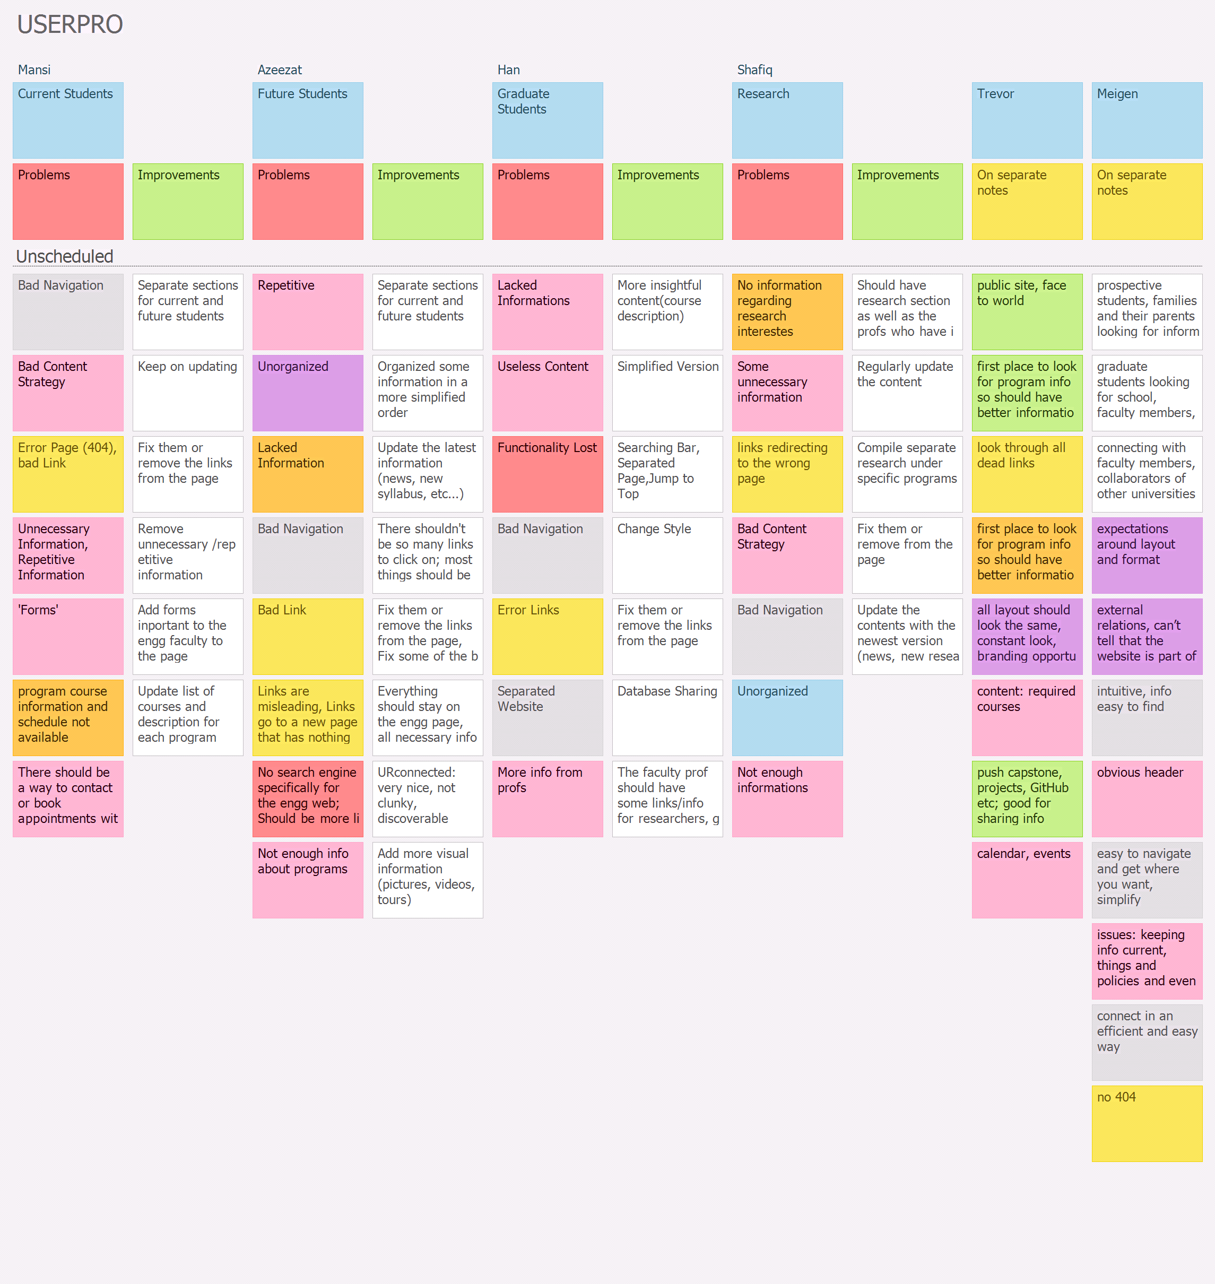

**Affinity Diagram:**

|  |  |  |  |  |  |
| --- | --- | --- | --- | --- | --- |
| **Content Strategy** | **Layout** | **Links** | **Navigation** | **Engineering Public Page** | **Functionality** |
| Unnecessary information, repetitive information,  useless content | Not same layout, No constant look | Program courses info and schedule not available | Bad navigation | Public site is the engineering face to world, branding opportunity for program | No search engine specifically for the engg web; should be more like the URconnected website |
| Lacks updated information like calendar, events, etc. | Unorganized | Error Page (404) | There are different websites for information that should be in engg website | First place to look for program info so it should have better information | Functionality lost |
| Program course information and schedule not available | Expectations around layout and format | Bad Links, Misleading, Bring to a separate webpage | Intuitive, info should be easy to find | Should push capstone, projects, GitHub etc; good for sharing info |  |
| Include forms | External relations, can’t tell that the website is part of university,  continuity | Lacked Information | Should be easy to navigate and get where you want; simplify |  |  |
| There should be a way to contact or book appointments with advisors |  | The first place to know about the program, so should have better information | Connect in an efficient and easy way |  |  |